- Day Data Analysis Project Report

Day 1-2: Project Setup The project topic was finalized and the dataset was collected. A proper folder structure was created to organize data, code, and reports.
Day 3: Data Exploration The dataset was loaded using pandas. Missing values and duplicates were handled. Basic statistics and data types were analyzed to understand the dataset.
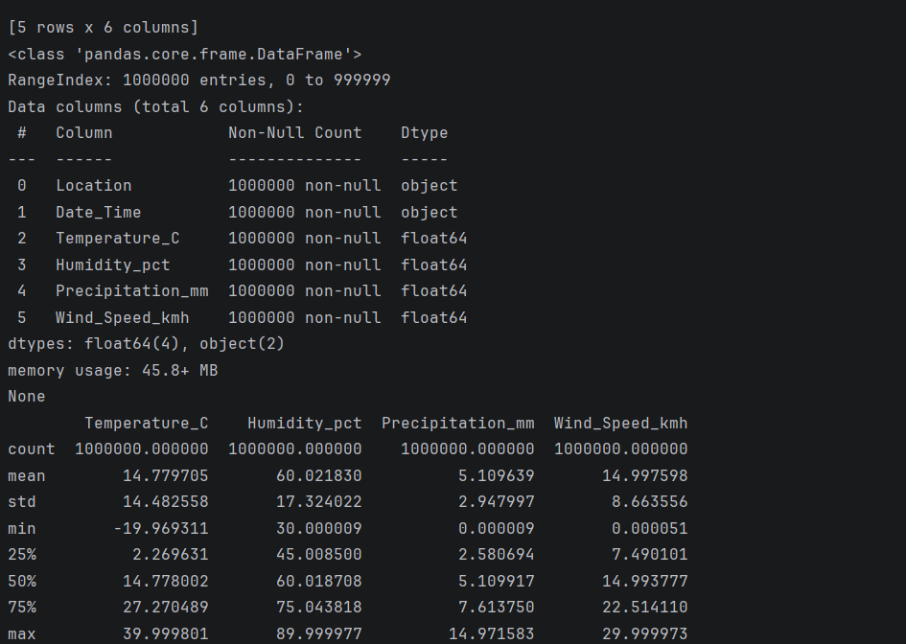

Day-4 Basic Analysis Key metrics such as average, maximum, and minimum values were calculated. Patterns and trends were identified from the data

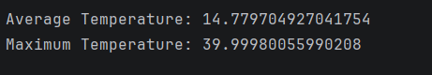

Day 5: Data Visualization Charts were created using matplotlib to visualize trends. To improve performance, data sampling and proper date formatting were applied.
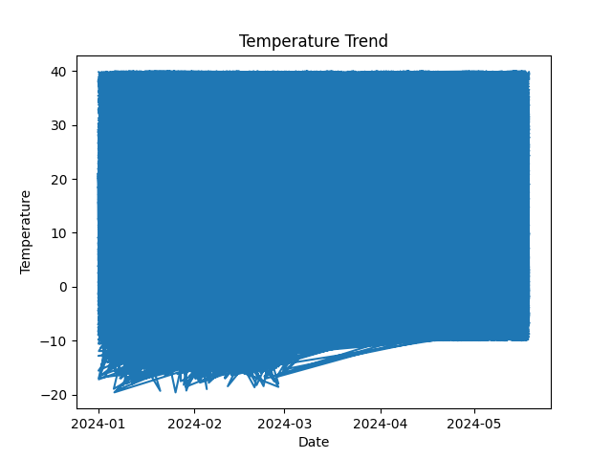

Day 6: Report Creation All findings, analysis, and visual insights were combined into a structured report with clear explanations.
Day 7: Finalization The project was tested, errors were fixed, and the final report was prepared for submission.
Conclusion This project demonstrates a complete data analysis workflow from data collection to visualization and reporting using Python.

